Quick Share

Root url - http://localhost:8080

Request - Get /{shareId}
Response -
{
"fileItemList": [
{
"id": "5138e5b6-52c2-4cca-914b-866bb07c1507",
"fileName": "Resume Final.pdf",
"fileLink": "https://drive.google.com/file/d/15RjgY0Rz6DcPKxwYy-LRYcJN3MQDx_Xw/view"
}
],
"textItemList": [
{
"id": "4cc7803e-9438-42c0-a5ec-c683f544350f",
"textContent": "Hii this is the first upload"
},
{
"id": "900101e8-76e7-43c3-83a6-6cd37fc51a5c",
"textContent": "Hii this is the this is second upload"
},
{
"id": "94cbe2f1-698f-4852-b6c9-c20563535655",
"textContent": "This is third upload"
}
]
}

- Request - POST /upload
For existing uploads
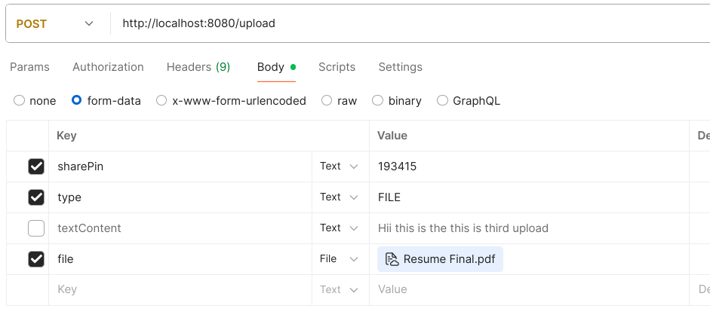
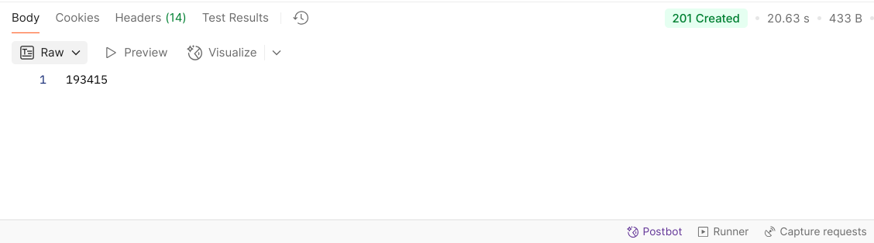

For new uploads
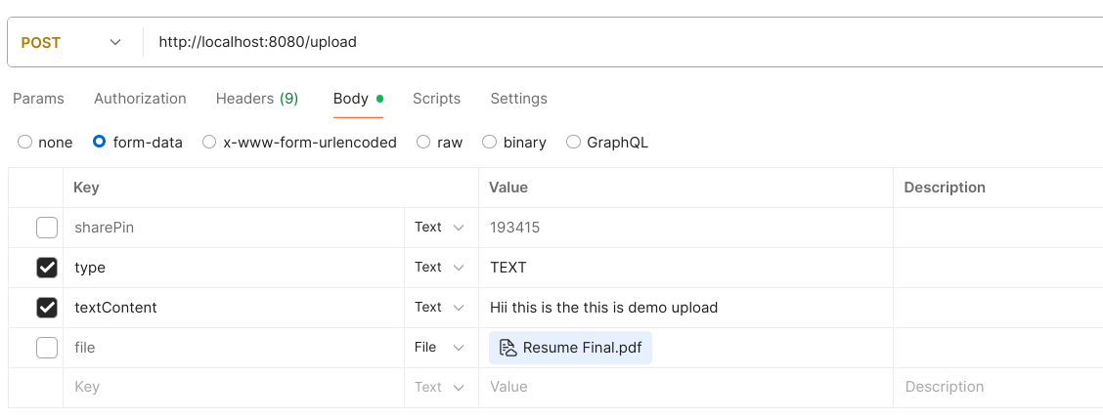
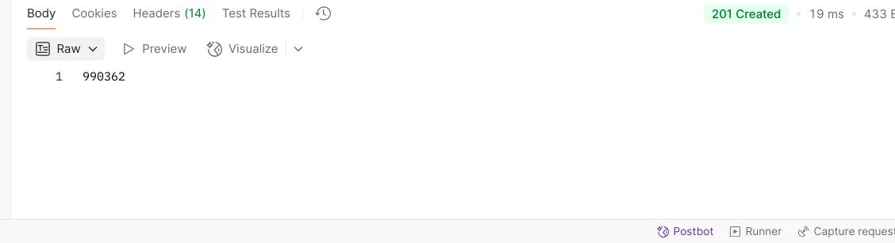
type = FILE/TEXT
sharePin (not for new upload)
Response - sharePin

return ResponseEntity
.status(HttpStatus.SC_CREATED)
.body(sharePin);

Error example
return ResponseEntity
.badRequest()
.body("File is required for FILE type");

- Patch - /{uuid}
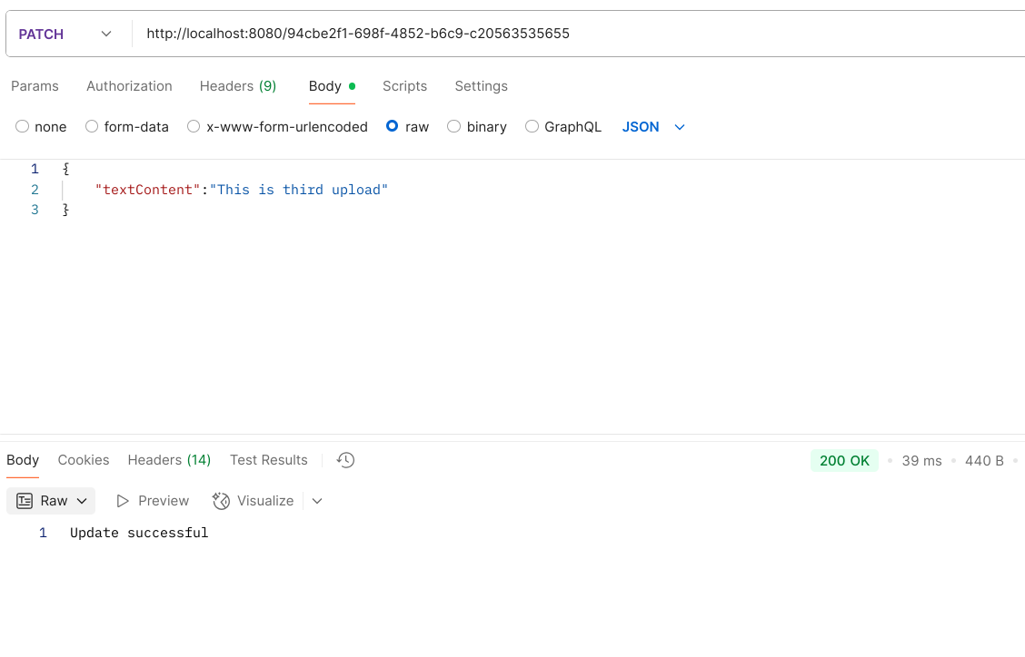
4.Delete - /{uuid}
return ResponseEntity
.ok("Deleted successfully");
For error
return ResponseEntity
.status(HttpStatus.SC_NOT_FOUND)
.body("Item not found");

